Lake Michigan Explorer User Guide
This user guide is designed to help educators (like you!) navigate the Lake Michigan Explorer and create a curriculum consisting of pre-existing lessons and resources to teach your students all about Lake Michigan and to advance their Great Lakes literacy. Utilizing this guide in conjunction with the fillable template will ensure success along the way.

Steps
- Review the Great Lakes literacy principles on the Center for Great Lakes Literacy website and select one principle to address in your curriculum development and add to your template.
- Considering other teaching needs and standards, decide if you would like to teach about Lake Michigan for three to ten class periods.
- Open up the Lake Michigan Explorer.
- Select your grade level on the age group filter.
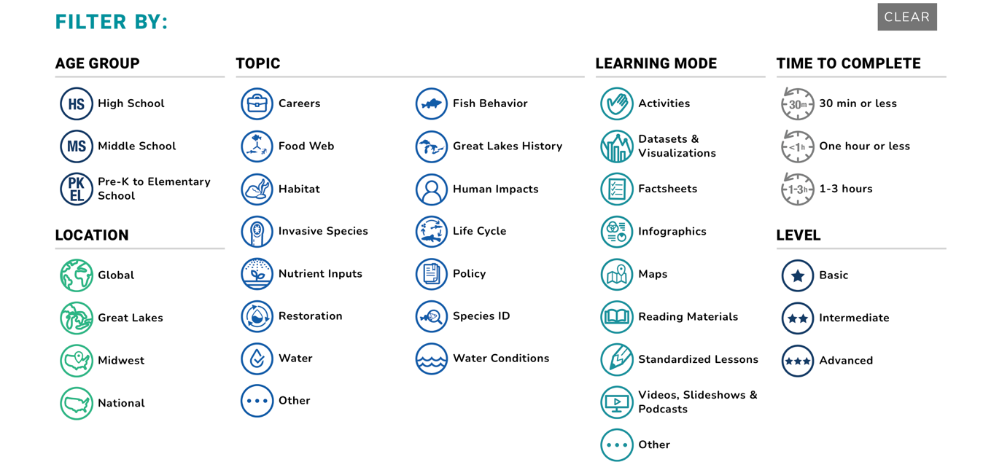
- Choose a combination of at least 1 basic,1 intermediate and 1 advanced level lessons to be able to teach about your selected Great Lakes literacy principle/state standards. Add the resource title, link, time to complete and levels to your template.
- Review the lesson materials for the selected resources to ensure they are suitable for your teaching needs and remove the ones that are not aligned.
- Using the ‘time to complete’ column of your template, check to ensure that enough lessons have been selected to teach your curriculum in the predetermined amount of time (refer to step 2).
- Happy Teaching!

Checklist

- Review the Great Lakes literacy principles on the Center for Great Lakes Literacy website
- Select one principle to address
- Choose three to ten class periods to teach
- Select grade level
- List includes at least 1 basic, 1 intermediate and 1 advanced level lesson
- Lessons chosen help you reach selected principle and standards
- Total time to complete corresponds to number of class periods

